Psion NEO Installation Instructions for Windows XP
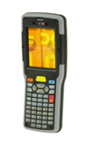
Ferguson ECOM Upload Application Installation Instructions
You have received a Psion NEO device that has been previously configured with the ECOM Application. Prior to use, you must also install Windows Mobile Device Center/Active Sync and the Upload Application onto your PC or laptop. To do so, please perform the following steps in this manual.
Contents
Psion NEO Installation Instructions for Windows XP 1
Equipment Validation and Windows version of your PC/Laptop 3
Installation Active Sync/Windows Mobile Device Center 5
ECOM Upload Application Download and installation 13
Equipment Setup 21
Initial Active Sync Setup for Windows XP 23

Equipment Validation and Windows version of your PC/Laptop

- You should have received a NEO handheld device, a docking/charging station, power cord, and USB cord. Please validate that you have received each. If you are missing any equipment, please contact Adam Jatich at TRG. His contact info is as follows:
Adam Jatich
Technology Recovery Group
440-788-2293
330-705-9366 (cell)
AJatich@TRGRepair.com
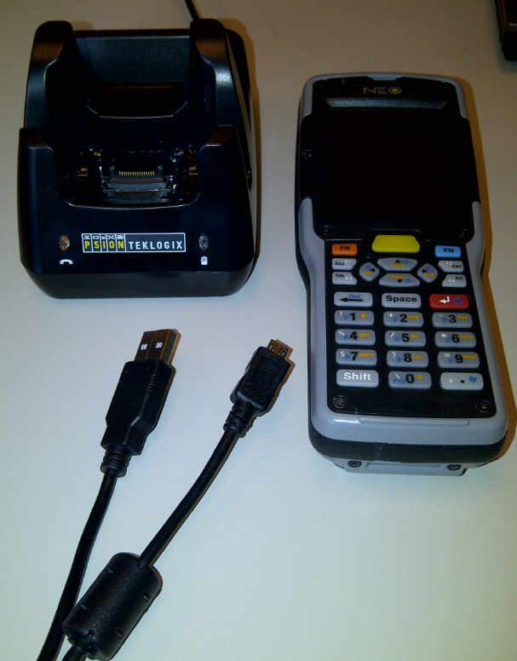
- On your laptop or PC, please validate your version of Windows. To do so, find the “My Computer” or “Computer” icon on your Desktop. It will look like this:

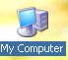

- Using your mouse, Right-Click on the “My Computer” icon and select “Properties”. A new screen will open and this will let you know the version of Windows that you have.
IF YOU SEE A WINDOW THAT LOOKS LIKE THIS ONE YOU HAVE WINDOWS XP. IF IT DOES NOT LOOK LIKE THIS, PLEASE SEE SEPARATE INSTRUCTIONS FOR WINDOWS 7 AND VISTA.

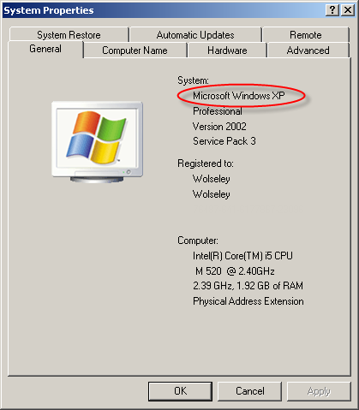

Installation Active Sync/Windows Mobile Device Center
You now need to download Active Sync/Windows Mobile Device Center. As a FYI, the handheld does not need to be docked or in use to do this. This will be specifically for your laptop or PC. Open Internet Explorer (do not use Chrome or Firefox) and navigate to the web address listed below:
Follow this link and instructions if you have Windows XP.
http://www.microsoft.com/download/en-us/details.aspx?id=15
The following are the steps you will take:
- Click “Continue”
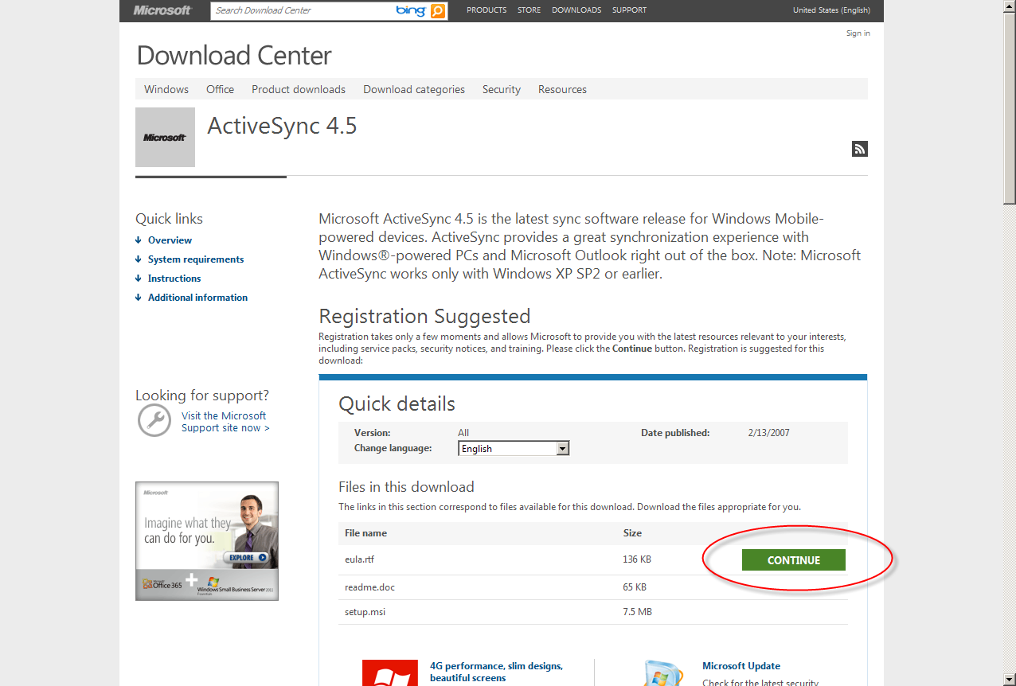

- Select the bullet that says “No, I do not want to register. Take me to the download.”
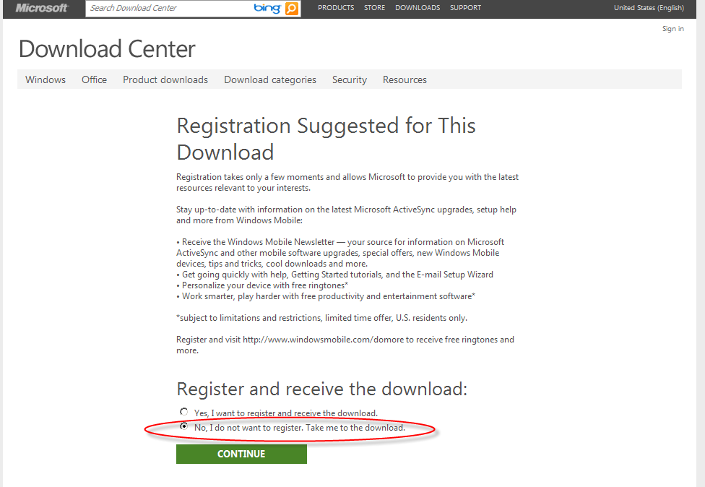
- Click the “setup.msi” Download button.
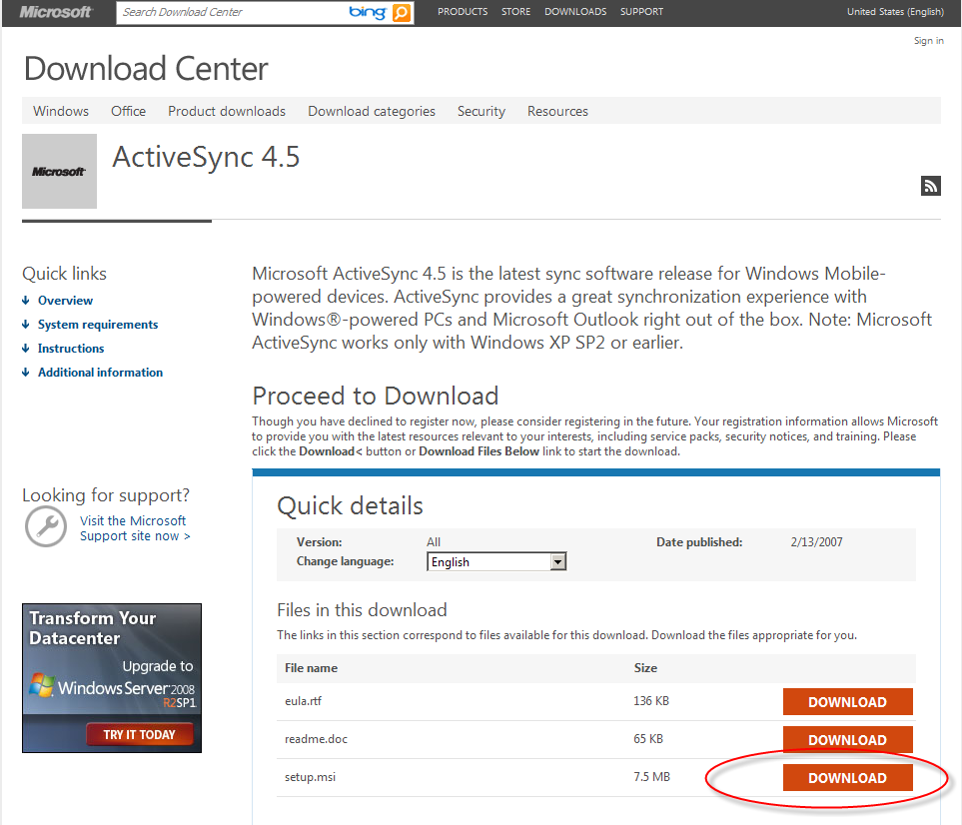
- Then click “Run”.
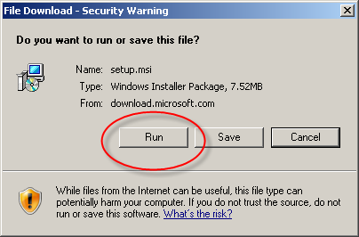
Important Note: If your window looks like the one below with no “Run” button, click “Save File” and “OK”.
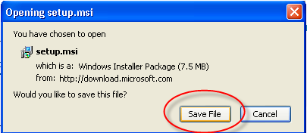
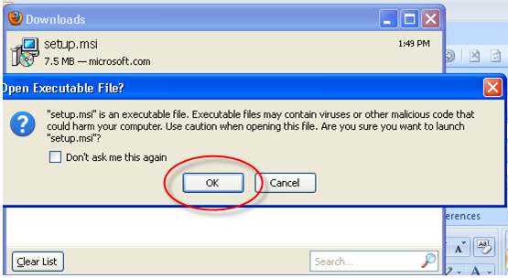
- Click “Run” again.
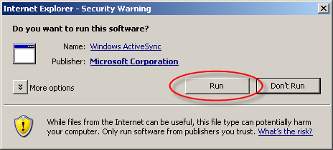
- Click “Next”
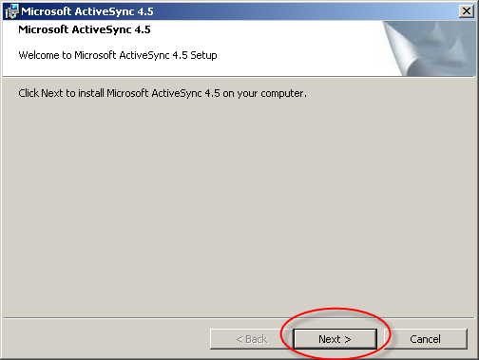
- Click “I accept the terms in the license agreement” and “Next”.
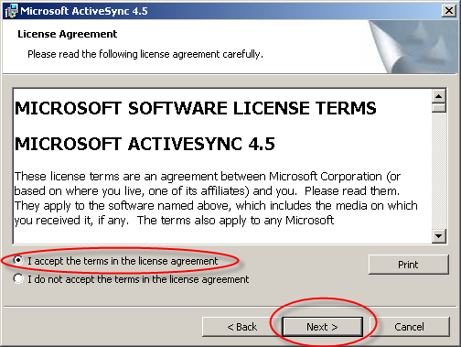
- Click “Next”. Note: The User Name and Organization will vary based on your system. There is no need to change either.
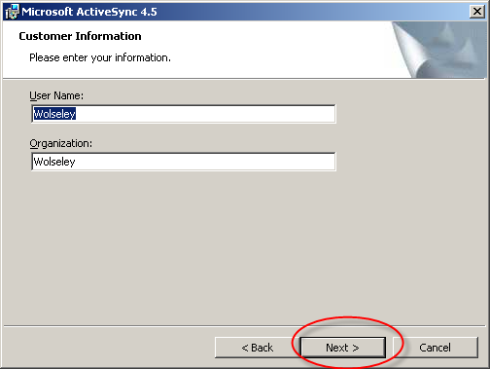
- If you would like to save ActiveSync somewhere other than the suggested folder, click “Change”. Otherwise, click “Next”.
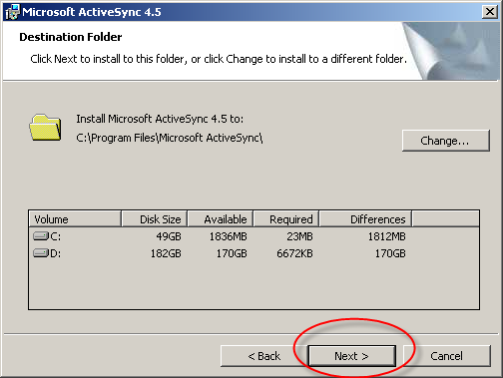
- Click “Install”.
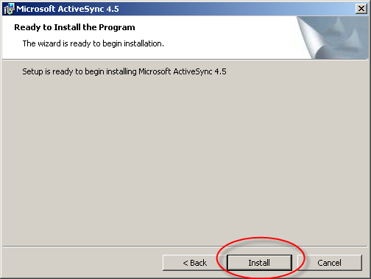
This process may take several minutes. You will see the blue status bar move as it processes.
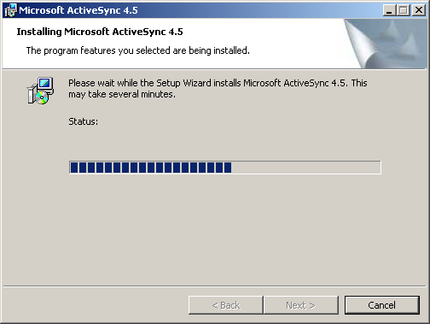
Important Note: If you get an error, click “OK”. If not go on to step 11.
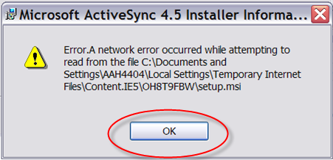
- When it finishes installing, click “Finish”.
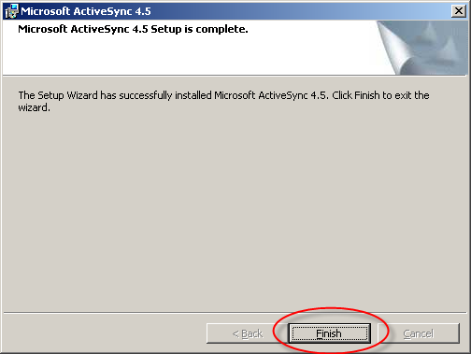
- You may get prompted to restart you computer. If so, restart and then continue with the instructions.
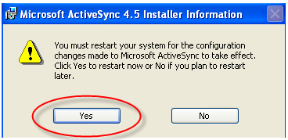

ECOM Upload Application Download and installation

It is now time to download the ECOM Upload Application. Please open Internet Explorer and navigate to the following webpage.

http://www.ferguson.com/professional/technology-solutions

It will be located under the “Ferguson Online” section of this page.

- Where it says “If you are using a Psion NEO scan gun and need to download the transfer program click here”, click the link.
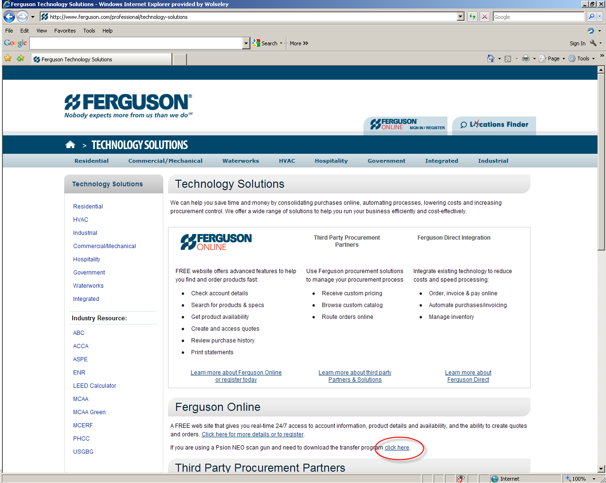
- You will be prompted to “Open” or “Save”. Click “Open”.
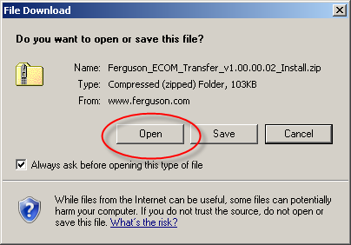

- At this window, click “File” in the top menu bar and then select “Extract All”.
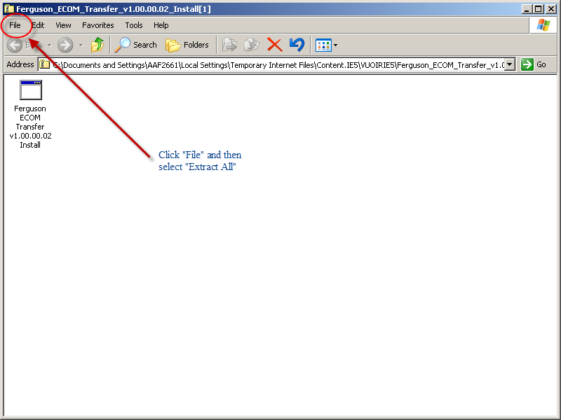

Important Note: If you are using Chrome, select “Extract All Files” in the left menu bar:
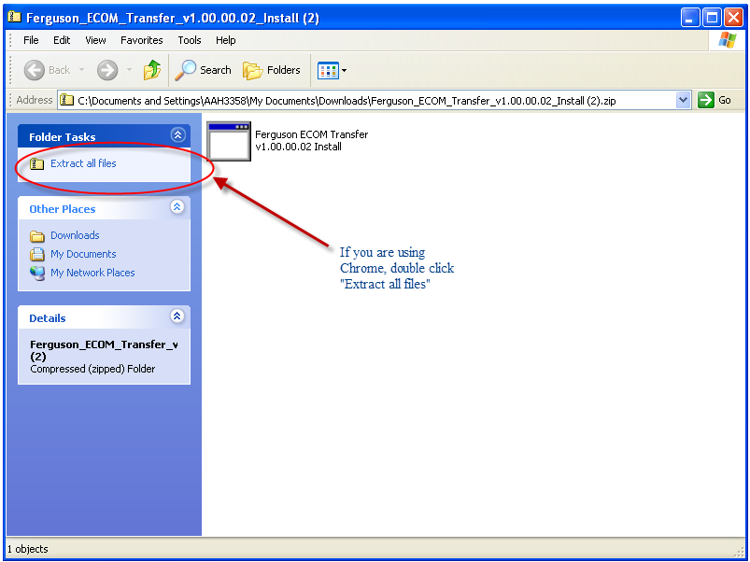
- You will get an Extraction Wizard window. Select “Next”.
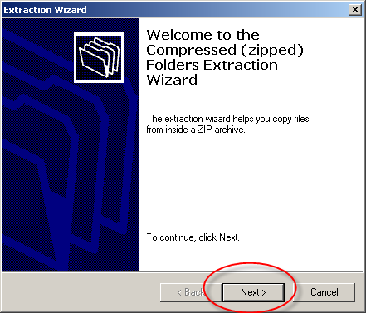
- On the “Select a Destination” window that appears, select “Next”.
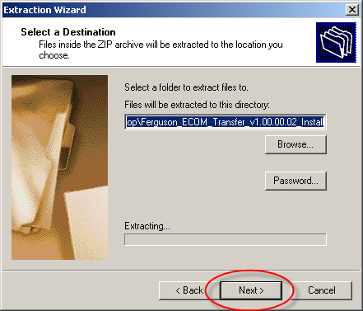

Important Note: You may or may not get a window like this. If so, on the “Confirm File Replace” window, select “Yes To All”. If you didn’t get this window, skip to number 6 and continue.
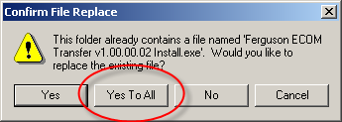

- You’ve now extracted all files. Select “Finish”.
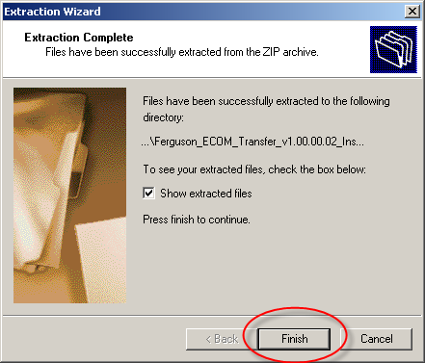

- Double click the Install program that appears.
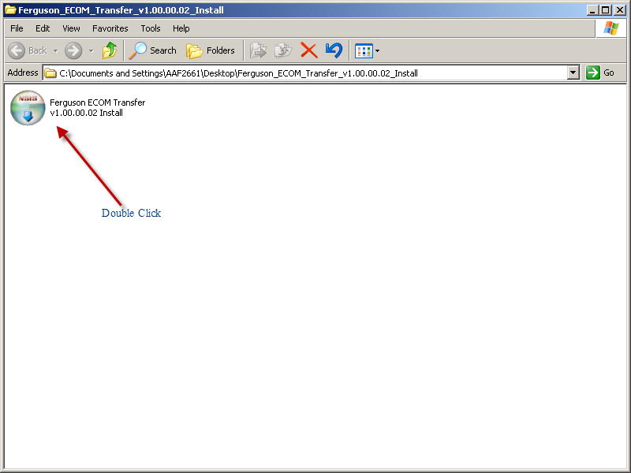
- It will say “The publisher could not be verified. Are you sure you want to run this software?”. Click “Run”.
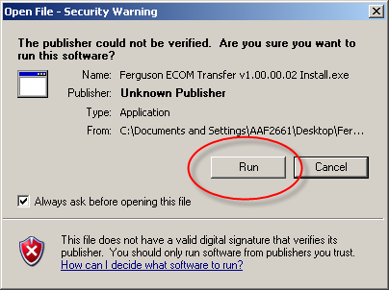

- You will be brought to the Ferguson ECOM Transfer Setup window. Click “Next”.
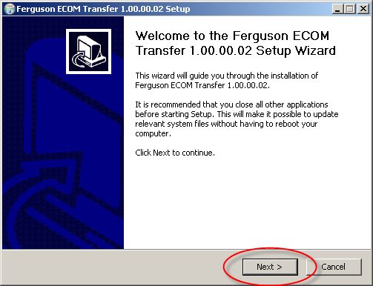

- When it tells you to Choose Components, click “Next”.
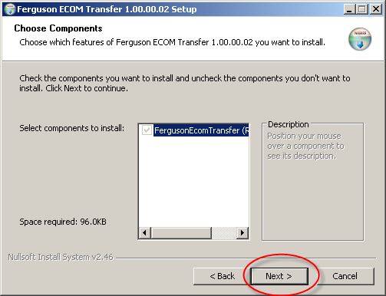

- It will ask you to choose install location. Click “Install”.
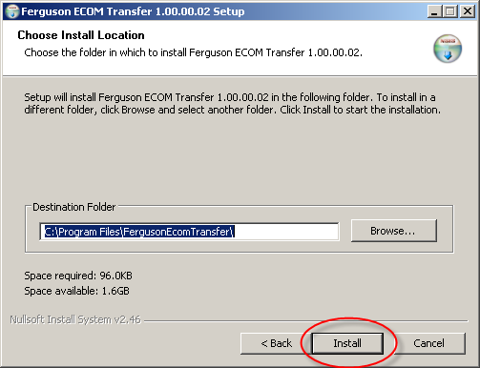

- You may get this window. Click “close”. If not, skip to step 14.
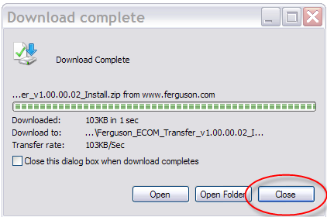
- You have completed the installation of the ECOM Transfer program. Click “Finish”. 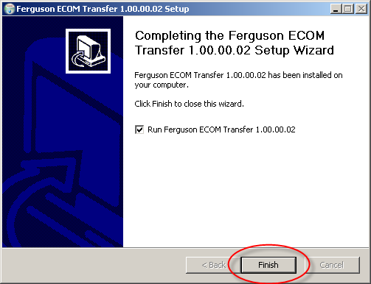
- The screen will disappear.

Equipment Setup
- Now that you have the required software to run the ECOM application, it is time to setup your equipment. Place the docking/charging system in a location within 6 feet of your PC and a power outlet so that the cords can reach. Plug the power cord into the back of the docking station and plug this into a wall outlet. This will allow you to charge the battery.
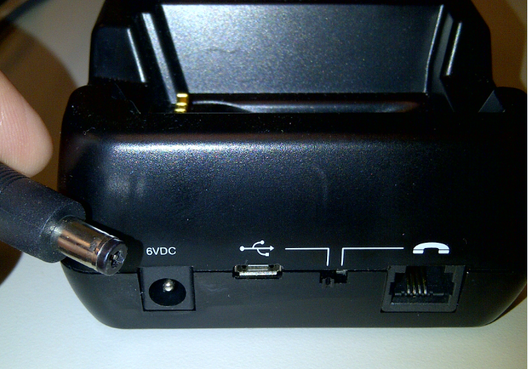

- Also, in the back of the docking station, place the smaller end of the USB cable into the plug with the US B marking.
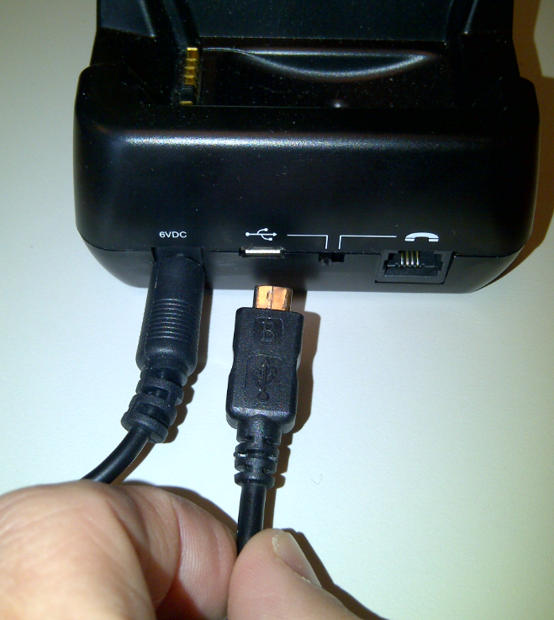

- Plug the other end of the USB cable into your PC or laptop.
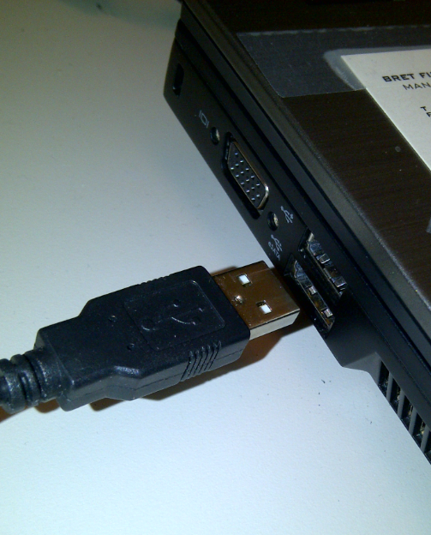
- Place the NEO Device into the docking station as depicted. This will allow you to both charge the battery of the device and upload your scans.
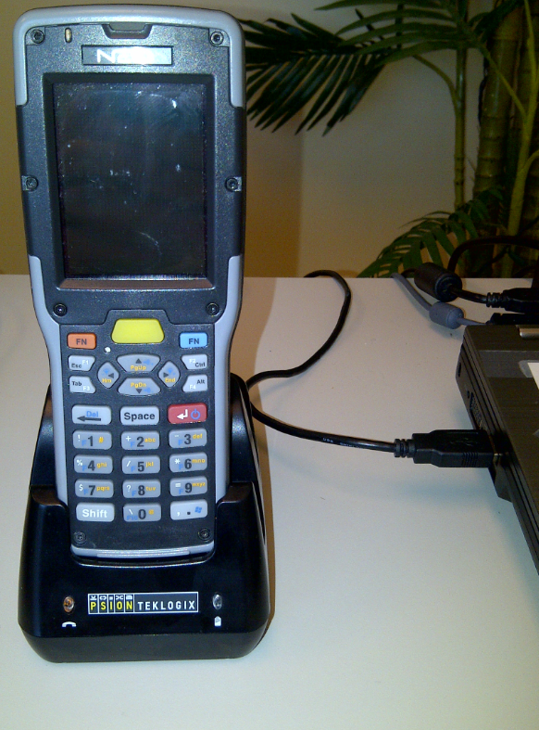

Initial Active Sync Setup for Windows XP
Upon docking your device for the first time, you will have to do a little bit of set up. Follow these instructions for the initial ActiveSync setup for Windows XP. After the initial setup you will not have to do anything when you dock your scan gun in its cradle. The ECOM upload application will begin to automatically upload the files that have been scanned.
- Begin by un-docking your gun and turning it on. Press and hold the red “Enter” button to turn on the gun. Then dock the scan gun in its cradle. ActiveSync will automatically kick off.
- You will see the following window pop up the very first time you dock the gun. Click “Next”.
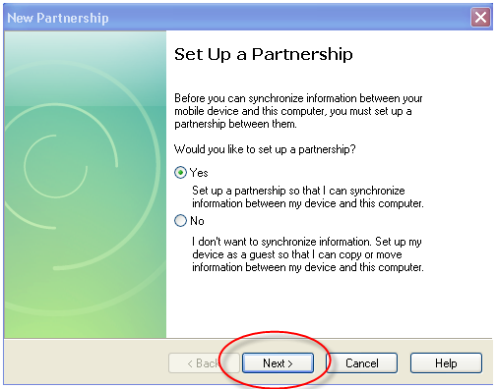

- You will be prompted to select the number of partnerships you would like to establish. If you will only linking the gun to the one PC that it’s attached to currently, leave the bullet on “Yes” and click “Next”. Otherwise, change the bullet to “No” and click “Next”.
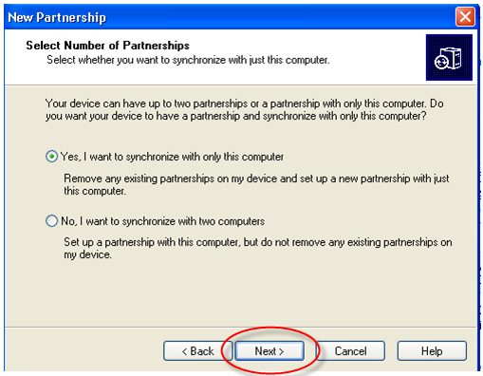
- On the “Select Synchronization Settings” window, uncheck/deselect all boxes and click “Next”.
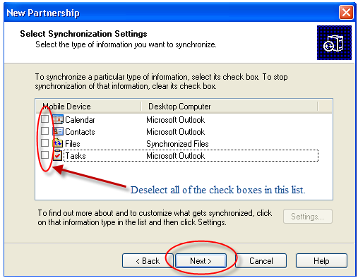
- Once the “Setup Complete” window comes up, click “Finish”.
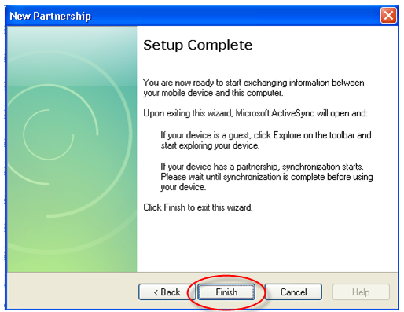
- Your ActiveSync window should be on your screen. This is the window you will see each time you dock the scan gun in its cradle.
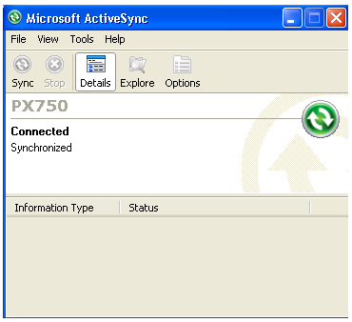
- You are now ready to scan. Please see the User Guide for detailed instructions on the scan gun software. If you do not have a User Guide, contact your Ferguson branch associate to get one.

If you have any issues installing anything on your PC or scan gun, please contact Mark Walker at Technology Recovery Group at 440-250-9896 or send him an email at mwalker@TRGRepair.com.

