Psion NEO Installation Instructions for Windows 7 and Vista
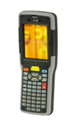
Ferguson ECOM Upload Application Installation Instructions
You have received a Psion NEO device that has been previously configured with the ECOM Application. Prior to use, you must also install Windows Mobile Device Center/Active Sync and the Upload Application onto your PC or laptop. To do so, please perform the following steps in this manual.
Contents
Psion NEO Installation Instructions for Windows 7 and Vista 1
Equipment Validation and Windows version of your PC/Laptop 3
Installation Active Sync/Windows Mobile Device Center 5
Windows Vista/Windows 7 (64 bit only) 8
ECOM Upload Application Download and installation 9
Equipment Setup 16
Initial Active Sync Setup for Windows 7 or Vista 18

Equipment Validation and Windows version of your PC/Laptop

- You should have received a NEO handheld device, a docking/charging station, power cord, and USB cord. Please validate that you have received each. If you are missing any equipment, please contact Stephanie Blatnicky from Psion. Her contact info is as follows:
Phone: (815) 722-1701
Email: Stephanie.blatnicky@psion.com

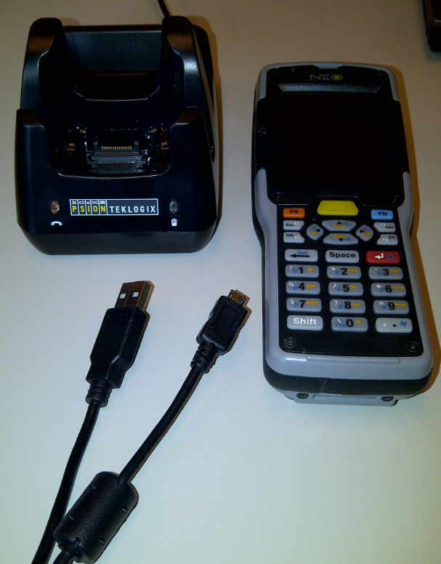
- On your laptop or PC, please validate your version of Windows. To do so, find the “My Computer” or “Computer” icon on your Desktop. It will look like this:

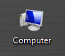

- Using your mouse, Right-Click on the “Computer” icon and select “Properties”. A new screen will open and this will let you know the version of Windows that you have.

IF YOU SEE A WINDOW THAT LOOKS LIKE THIS ONE YOU HAVE WINDOWS 7 OR VISTA. FOLLOW THE ACTIVESYNC INSTRUCTIONS BELOW FOR WINDOWS 7.
Windows 7 can be 32 bit or 64 bit so please note this as well.
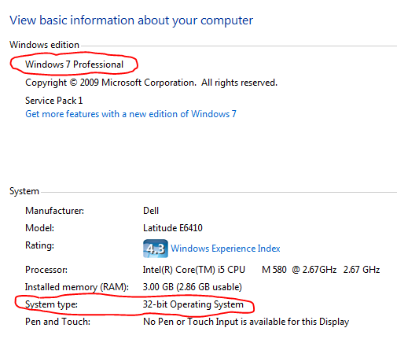

Installation Active Sync/Windows Mobile Device Center
You now need to download Active Sync/Windows Mobile Device Center. As a FYI, the handheld does not need to be docked or in use to do this. This will be specifically for your laptop or PC. Open Internet Explorer and navigate to the web address listed below:
Follow this link and instructions if you have Windows Vista / Windows 7 (32 bit)
http://www.microsoft.com/download/en/details.aspx?id=14
The following are the steps you will take:
- You will come to a screen that looks like this. You will need to click the “continue” button.
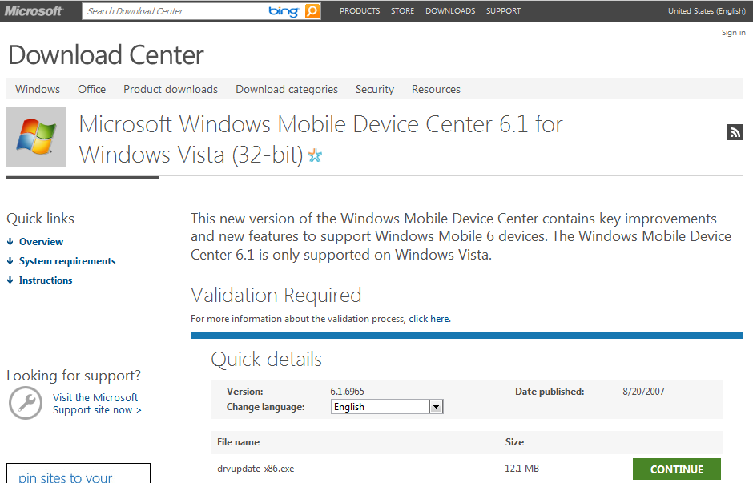

  - If you get a screen like this, click “Continue”. Otherwise, skip to step 2.
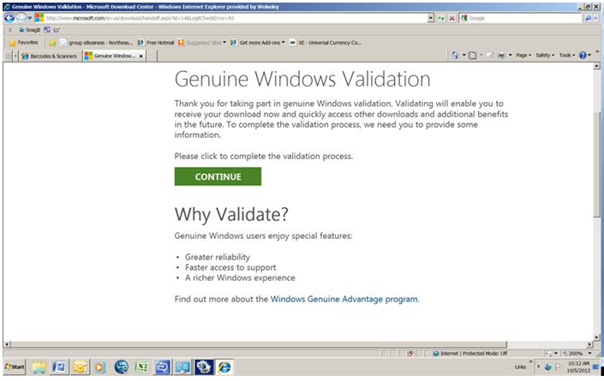
  - If you click “Continue” you may see the following screen:
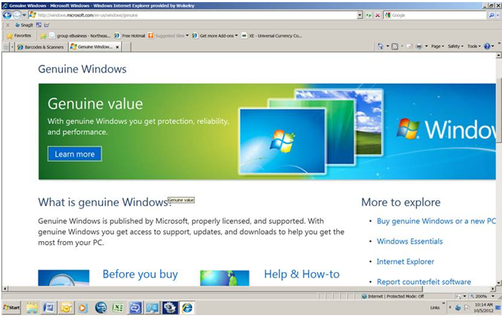
  - If you get the screen above, please use the following link to download Windows Mobile Device Center using the following link (for 32-bit):
http://download.cnet.com/Microsoft-Windows-Mobile-Device-Center-for-Windows-Vista-32-bit/3000-2094_4-10714488.html?tag=bc
  - If you get the screen above and you are using 64-bit, then use the following link to download Windows Mobile Device Center:
http://download.cnet.com/Microsoft-Windows-Mobile-Device-Center-for-Windows-Vista-64-bit/3000-2094_4-10714491.html?tag=bc
  - You should come to the following screen. Click “Download Now”.
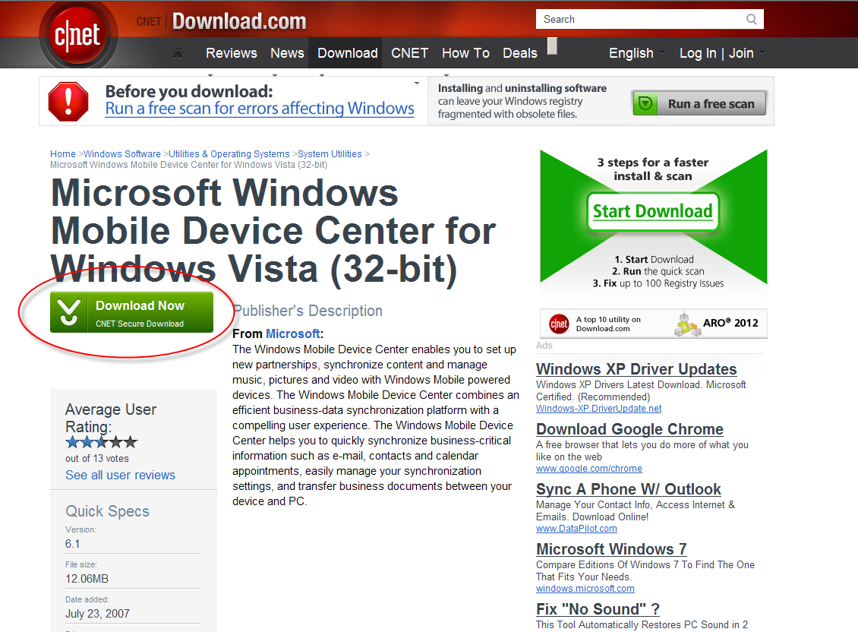

- You will come to the following screen. Click Download Now.
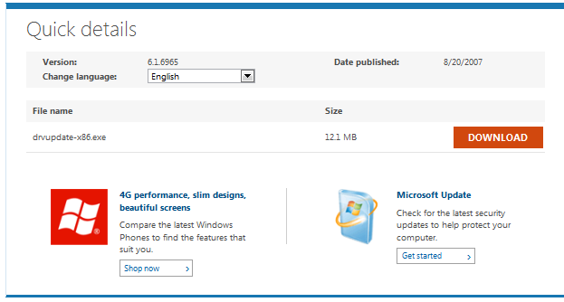
You will get the following pop-up window. Click Run

You may see the following:
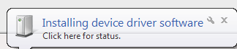

The install will complete and you will see the following. Please note, the install worked correctly!! It is just looking for a device so it gives you the following message that just confuses everyone. Rest assured the install is good.
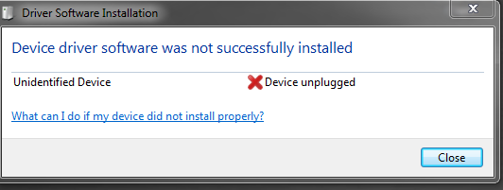
To validate, upon completion of the install, you will notice the following icon in the lower-right hand corner of your PC/laptop:

Windows Vista/Windows 7 (64 bit only)
Follow this link and instructions if you have Windows Vista / Windows 7 (64 bit)
http://www.microsoft.com/download/en/details.aspx?id=3182
You will follow the same process as the 32-bit screen shots above.

ECOM Upload Application Download and installation

It is now time to download the ECOM Upload Application. Please open Internet Explorer and navigate to the following webpage.

http://www.ferguson.com/professional/technology-solutions

It will be located under the “Ferguson Online” section of this page.

- Where it says “If you are using a Psion NEO scan gun and need to download the transfer program click here”, click the link.
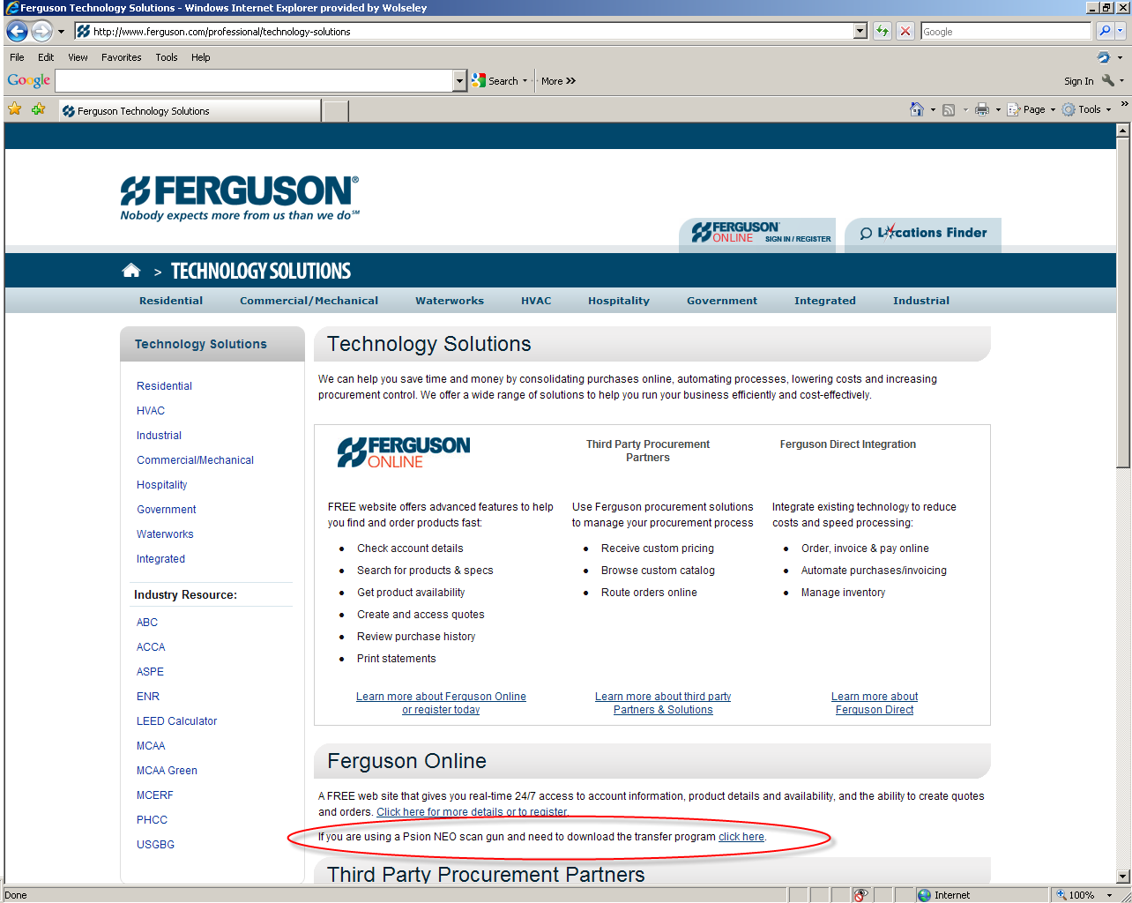

- The “Run” window will pop up. Click “Save”.
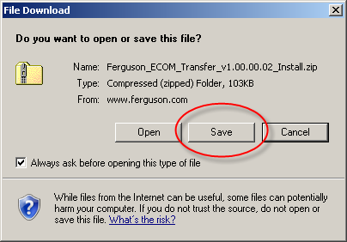

- Select “Desktop” on the left and then click “Save”.
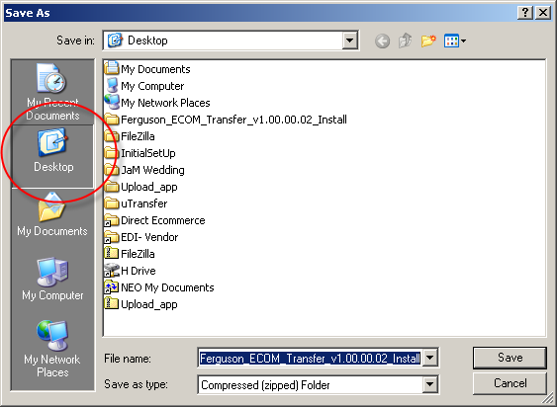

- Go to your desktop and locate the newly saved program zip file.
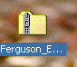

- Right click the file and select “Extract All”. You will get an Extraction Wizard window. Select “Next”.
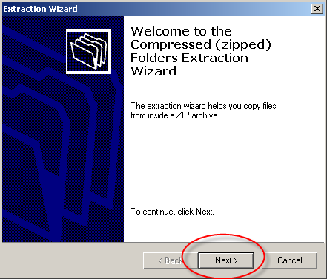

- On the “Select a Destination” window that appears, select “Next”.
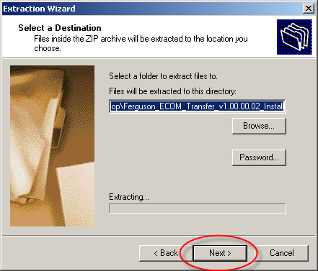

- You may or may not get a window like this. If so, on the “Confirm File Replace” window, select “Yes To All”. If you didn’t get this window, skip to number 8 and continue.
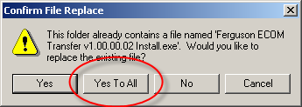
- You’ve now extracted all files. Select “Finish”.
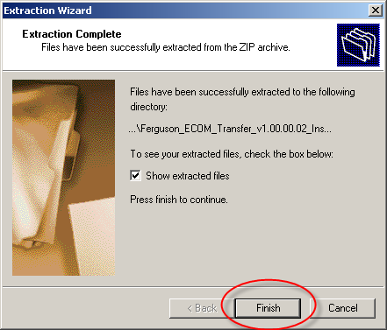

- Double click the Install program that appears.
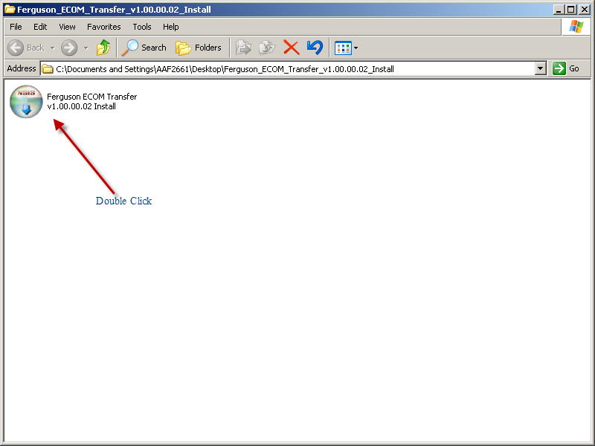
- It will say “The publisher could not be verified. Are you sure you want to run this software?” Click “Run”.
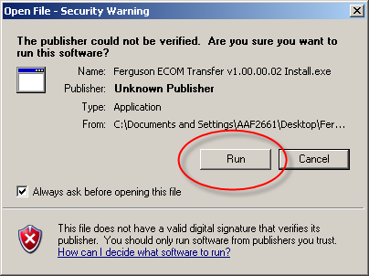

- You will be brought to the Ferguson ECOM Transfer Setup window. Click “Next”.
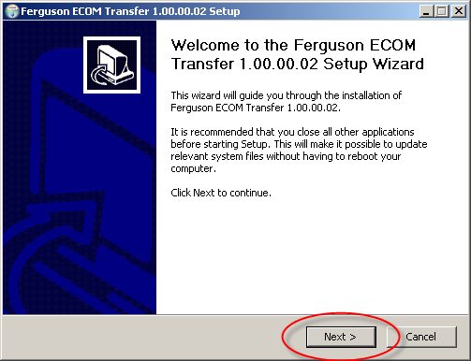
- When it tells you to Choose Components, click “Next”.
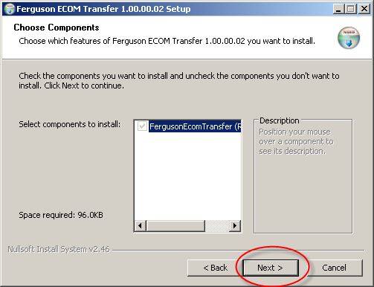

- It will ask you to choose install location. Click “Install”.
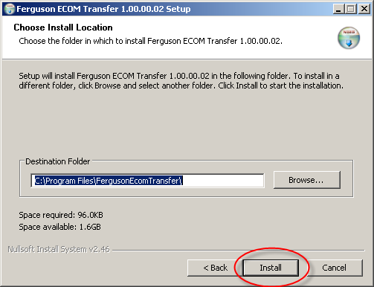

- You have completed the installation of the ECOM Transfer program. Click “Finish”. 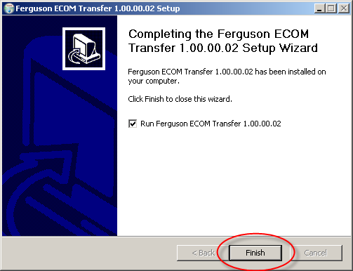
- The screen will disappear.

Troubleshooting:

Equipment Setup
- Now that you have the required software to run the ECOM application, it is time to setup your equipment. Place the docking/charging system in a location within 6 feet of your PC and a power outlet so that the cords can reach. Plug the power cord into the back of the docking station and plug this into a wall outlet. This will allow you to charge the battery.
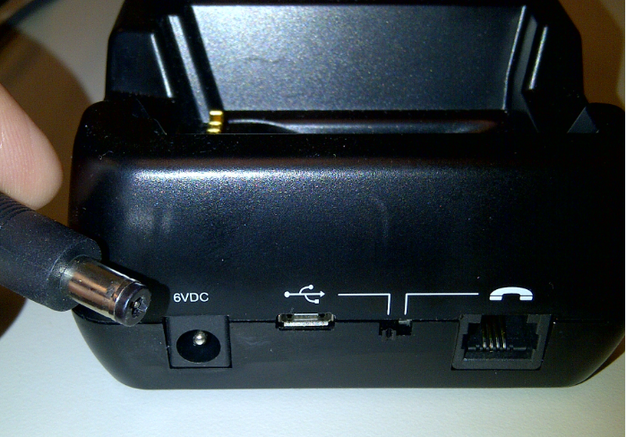

- Also, in the back of the docking station, place the smaller end of the USB cable into the plug with the US B marking.
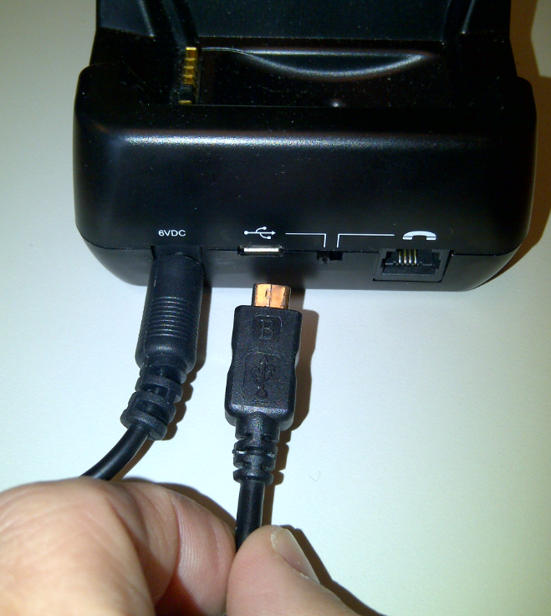

- Plug the other end of the USB cable into your PC or laptop.
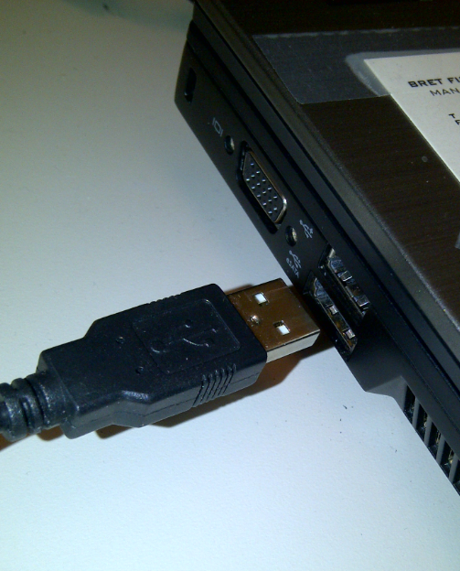

- Place the NEO Device into the docking station as depicted. This will allow you to both charge the battery of the device and upload your scans.
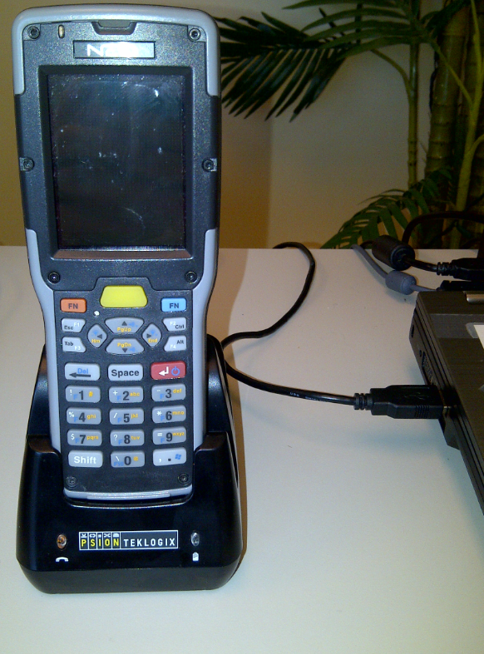

Initial Active Sync Setup for Windows 7 or Vista
Upon docking your device for the first time, you will have to do a little bit of set up. Follow these instructions for the initial ActiveSync setup for Windows 7 or Vista. After the initial setup you will not have to do anything when you dock your scan gun in its cradle. The ECOM upload application will begin to automatically upload the files that have been scanned.

Active Sync will open the first time when a device is connected and you will see the following screen:
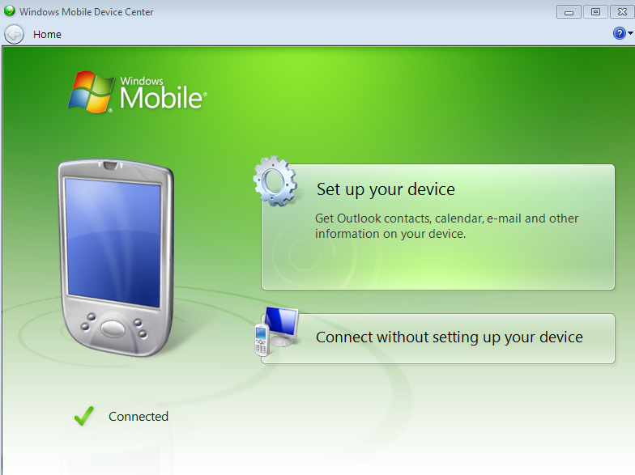

- Click “Set up your device” and you will see the following:
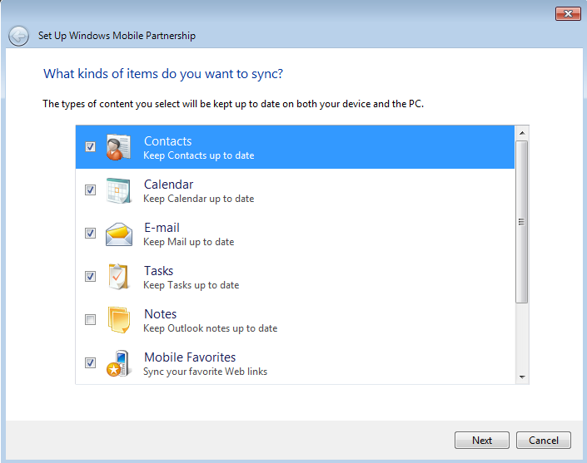
- Deselect all items. Then click the NEXT button at the bottom of the screen.
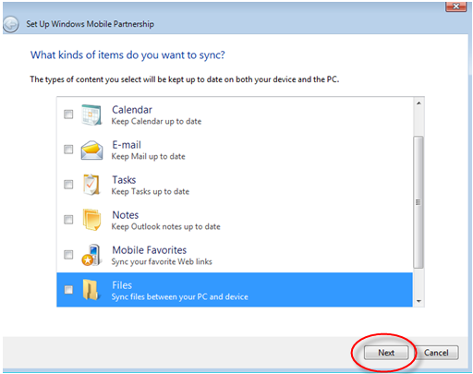
You are now ready to use your scan gun.

If you have any issues installing anything on your PC or scan gun, please contact Technology Recovery Group at XXX-XXX-XXXX.

